Algebra 3-4 Name: _______________________
Worksheet 1.3 Block: ______

Solve the equation for the variable.

1. x – 8 = 12 2. 2x + 3 = 7

3. 5x – 2 = 13 4. 6 – x = 4

5. 9 – 3x = -3 6. 8x + 3 = 5

7. 3x – 5 = 9 8. x + 4 = 2x + 9

9. 3x – 1 = x + 4 10. 4 + 5x = x – 8

11. 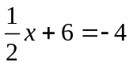 12. 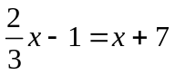

13. -(x + 1) = 2(3x – 1) 14. 3(x – 2) = 5(4 + x)

15. 2(7 – x) = 6(1 + 2x) 16. 3(x + 4) = 3(8 – 2x)

17. 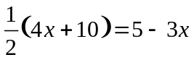 18. 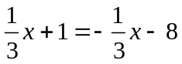

19. 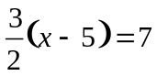 20. 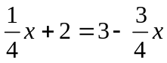

21. 5(2x – 2) = 4 – 2x

